Registration Form
Participant cost for this course is $XXX.XX payable via direct deposit, details below. To confirm your place, please send completed registration details, including payment by XXXXXXXXXXXXX.
Name:
Address:
Suburb:
Postcode/State:
Phone:
Email:
Religious Affiliation:
Experience/Qualification in Children’s Religious Formation (please indicate any applicable)
Classroom Teacher | Early Childhood Educator | Montessori trained
Parent | Grandparent | Catechist
Payment Options – please enter details
Please return forms:
Via email: xxx@xxxx
Via Post: XXXXXXXXXXXXXXXXXXXXX
□ Direct Deposit  Date  Amount  Reference  (SURNAME) | Account Name: XXXXXXXXXX  BSB: XXXXXX  Acct Number: XXXXXXXXXX  Direct Deposit Details
□ Cheque | Please make cheques payable to  XXXXXXXXXXX
The Catechesis of the
Good Shepherd

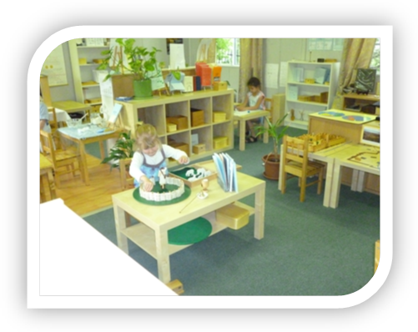
A Formation Experience for adults working with
children aged 3 to 6 years

Level One: Part One
(7 Days)
Location- Year

Add the dates here
Plus any other info

Introduction
The Catechesis of the Good Shepherd is a Christian formation process for children between the ages of 3 and 12 years. The central aim of this faith formation program is to enable the child to experience and form an authentic relationship with God.

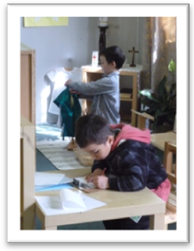The Catechesis is grounded in scripture and the liturgy of the church, then framed by Montessori principles of education. This allows children to hear the Gospels through the use of sensorial rich materials. The children are free to work with these materials that represent essential proclamations of the Christian message.

The adult’s task is to prepare the sacred space for the children called the Atrium, so that they can respond to this relationship, first proclaimed to them through Jesus the Good Shepherd.

The Atrium is a place of community and worship rather than a place of academic study. It is a place to be with and enjoy God, listen to the Word and to pray. It is designed to reflect the beauty of creation and God’s abiding love.

The vision for this faith formation began in 1954 with Dr. Sofia Cavalletti, a Hebrew and scripture scholar and member of the Vatican Commission for Jewish Christian relations and her colleague, Professor Gianna Gobbi, a Montessori Educator.

Dr. Cavalletti began her work of the Catechesis of the Good Shepherd with young children in Rome, Italy. She found that in working with children in this way, whatever their culture, they have vital religious needs and they respond in similar ways to the most essential elements of the Christian message.

Children desire to be near to God but need the sensitive guidance of the adult as well as the inner guidance of the Holy Spirit to nurture this relationship.

Today, the Catechesis of the Good Shepherd has grown and spread amazingly. At last count, CGS is present in 39 different countries around the world.

Course Description and Aims

The Level One Formation Course is the foundation course for all three levels of the Catechesis of the Good Shepherd program. It aims to:

- To explore with participants the general developmental characteristics, religious nature and religious needs of the 3 to 6 year old child.
- To meditate on the Biblical and Liturgical themes of the Catechesis of the Good Shepherd. This method was first developed by Dr. Sofia Cavalletti and Professor Gianna Gobbi in Rome, Italy and has been used now for over sixty years in various places throughout the world.
- To offer guidelines and assistance to catechists in setting up an atrium for the 3 to 6 year old child, preparing presentations, album pages and making materials.
- To experience being formed as catechists by the Word of God and deepening our ability to observe and learn from the children the joy of the Gospel!

Course Details
This course is Part One of the full Level One Course and consists of 48 hours of formation which will be offered over 6.5 days.
Participants who complete Level I Part I, will be able to continue formation & register for Level I Part Two.

Course Dates 2021
Add days and dates and times

Course Venue
XXXXX
XXXXXXXXXXX
What to Expect from the Course
“If we want to help the child draw nearer to God,
we should with
patience and courage
seek to go always closer
to the vital nucleus of things.

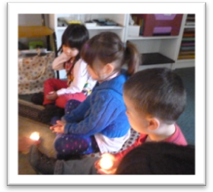
This requires study and prayer.

The children will be our teachers if we know how to observe them.”
Sofia Cavalletti
Founder Catechesis of the Good Shepherd
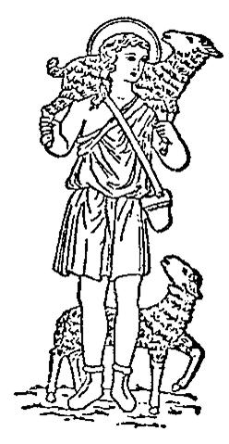

This 48 hour formation course is a personal retreat as well as providing participants with the necessary background to set up a prepared environment and begin working with 3-6 year old children in the Catechesis of the Good Shepherd. The course covers the pedagogy, history, philosophy, theology, liturgy and practical working with and making materials for the Catechesis of the Good Shepherd.

Although designed for training catechists, this course is an opportunity for personal faith formation and enrichment, and an opportunity to deepen your understanding of the development of children in this age group.

Kathy Menzies and Kate Anderson will be the facilitators of this course. Both have had fifteen years of experience working with this method and have completed formation at all three levels in this work. They are recognised nationally as formation leaders for the Catechesis of the Good Shepherd. Bring along your bible, a notebook, paper, pens, charged laptop, and camera (if you wish), but please no video devices.

Please bring your own lunch and snacks (there is a microwave available). Tea and Coffee will be provided.

Expectations of Participants 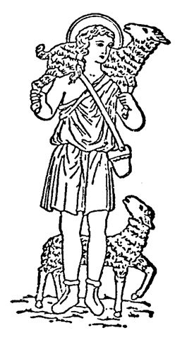
Suggested reading:
- The Religious Potential of the Child
- The Good Shepherd and the Child: A Joyful Journey
- Listening to God with Children

These publications are available from the National Association of the Catechesis of the Good Shepherd and online. It is suggested that participants have their own copy of each book at the course and attend all 6.5 days.

Participants who attend all sessions will receive a certificate from the National Association of the Catechesis of the Good Shepherd. This is an internationally recognised Certificate.
For further information contact:

Add any contact information

